

Course Title: Web Technologies Lab

Course Code: 21CSA286

PROJECT REPORT

**LEGENDARY MOTORSPORT**

Team 13:

Saran Shabu – MY.SC.I5MCA21039

Arjun U Menon – MY.SC.I5MCA21010

Sreeshanth P – MY.SC.I5MCA21005

Anushob K Anand – MY.SC.I5MCA21024

**AUTOMOBILE DEALERSHIP MANAGEMENT SYSTEM**

Submitted to

Rachana.S

Assistant Professor

Amrita School Of Computing

**Abstract**

This project report presents the development and implementation of Legendary Motorsport, a GTA 5 car dealership website that allows users to browse and purchase virtual cars from the popular video game. The website features user registration and login functionalities, enabling personalized experiences for visitors. Additionally, an order tracking system is implemented to provide users with the ability to monitor their purchases. The report discusses the key features, technologies used, challenges faced, and the overall success of the project. The website's design focuses on user-friendliness and aesthetics, while the backend includes an inventory management system to ensure accurate and real-time information. By providing a seamless and engaging platform for GTA 5 car enthusiasts, Legendary Motorsport aims to create an enjoyable and immersive shopping experience.

**Introduction**

The Legendary Motorsport project aimed to create an immersive and user-friendly car dealership website that offers virtual cars from the popular video game Grand Theft Auto V (GTA 5) for sale. The objective was to provide enthusiasts of the game with a platform where they could explore, purchase, and track their orders of virtual vehicles within the GTA 5 universe. The website incorporated essential features such as user registration and login, allowing users to create personalized accounts and access exclusive features.

In the world of GTA 5, vehicles play a significant role in the gameplay experience. With Legendary Motorsport, we sought to bridge the virtual and real worlds by offering users the opportunity to own their favorite virtual cars in the game. The website's design aimed to captivate users from the moment they landed on the homepage, showcasing featured cars, the latest arrivals, and popular vehicle categories. Our priority was to create an intuitive and visually appealing user interface that would enhance the overall browsing and purchasing experience. Behind the scenes, the website implemented a robust backend system to manage the car inventory, ensuring that the available stock information was accurate and up to date.

**Flow-Chart**

The given flow chart consists of several components,

1. Initiation,
2. Processes that represent the Webpages,
3. Manual inputs that the user inputs for the next page,
4. Databases for both sales and user registration and log-in, and
5. Termination.

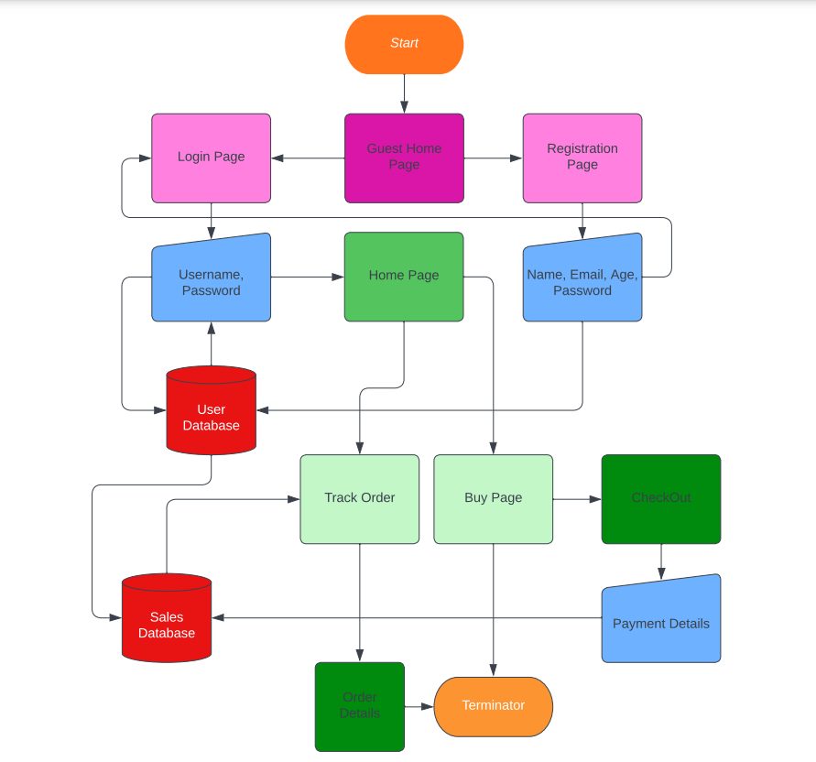

**Code Snippets**

1. **HomeOG.html**

<!doctype html>

<html>

<head>

<meta charset="UTF-8">

<title>L.A. Home</title>

<meta name="description" content="Scarica gratis il nostro Template HTML/CSS GARAGE. Se avete bisogno di un design per il vostro sito web GARAGE può fare per voi. Web Domus Italia">

<meta name="author" content="Web Domus Italia">

<meta http-equiv="X-UA-Compatible" content="IE=edge,chrome=1">

<meta name="viewport" content="width=device-width, initial-scale=1.0">

<link rel="stylesheet" type="text/css" href="source/bootstrap-3.3.6-dist/css/bootstrap.css">

<link rel="stylesheet" type="text/css" href="source/font-awesome-4.5.0/css/font-awesome.css">

<link rel="stylesheet" type="text/css" href="style/slider.css">

<link rel="stylesheet" type="text/css" href="style/mystyle.css">

<script>

function subscribe() {

var email = document.getElementById("subemail").value;

if (email == "")

alert("Please enter your email address.")

else

alert("Thank you for subscribing to our news letter.");

}

</script>

</head>

<script>

function Ocelot() {

window.location.href="BuyPage/buynowOcelot.html";

}

function Enus() {

window.location.href="BuyPage/buynowEnus.html";

}

function Jester() {

window.location.href="BuyPage/buynowJester.html";

}

function Turismo() {

window.location.href="BuyPage/buynowTurismo.html";

}

function Obey() {

window.location.href="BuyPage/buynowObey.html";

}

function Itali() {

window.location.href="BuyPage/buynowItali.html";

}

function SC1() {

window.location.href="BuyPage/buynowSC1.html";

}

function Cinferno() {

window.location.href="BuyPage/buynowCInfernus.html";

}

function Comet() {

window.location.href="BuyPage/buynowComet.html";

}

function Cheetah() {

window.location.href="BuyPage/buynowCheetah.html";

}

</script>

<body>

<!-- Header -->

<div class="allcontain">

<div class="header">

<ul class="socialicon">

</ul>

<ul class="givusacall">

<li>Give us a call (Toll-Free) : +91 999-888-6677 </li>

</ul>

<ul class="logreg">

<li>W E L C O M E B A C K </li>

</ul>

</div>

<!-- Navbar Up -->

<nav class="topnavbar navbar-default topnav">

<div class="container">

<div class="navbar-header">

<button type="button" class="navbar-toggle collapsed toggle-costume" data-toggle="collapse" data-target="#upmenu" aria-expanded="false">

<span class="sr-only"> Toggle navigaion</span>

<span class="icon-bar"></span>

<span class="icon-bar"></span>

<span class="icon-bar"></span>

</button>

<a class="navbar-brand logo" href="#"><img src="img3/gtav-removebg-preview (1).png" alt="logo"></a>

</div>

</div>

<div class="collapse navbar-collapse" id="upmenu">

<ul class="nav navbar-nav" id="navbarontop">

<li class="active"><a href="#">HOME</a> </li>

<li class="dropdown">

<a href="#" class="dropdown-toggle" data-toggle="dropdown" role="button" aria-haspopup="true" aria-expanded="false">CATEGORIES <span class="caret"></span></a>

<ul class="dropdown-menu dropdowncostume">

<li><a href="#">Sports</a></li>

<li><a href="#">Sports Classics</a></li>

<li><a href="#">Hypercar</a></li>

</ul>

</li>

<li class="dropdown">

<a href="#" class="dropdown-toggle" data-toggle="dropdown" role="button" aria-haspopup="true" aria-expanded="false">DEALERS <span class="caret"></span></a>

<ul class="dropdown-menu dropdowncostume">

<li><a href="#">Los Santos</a></li>

<li><a href="#">Las Venturas</a></li>

<li><a href="#">San Fierro</a></li>

</ul>

</li>

<button onclick="golp()"><span class="postnewcar">TRACK YOUR ORDER</span></button>

</ul>

</div>

</nav>

</div>

<!--_______________________________________ Carousel__________________________________ -->

<div class="allcontain">

<div id="carousel-up" class="carousel slide" data-ride="carousel">

<div class="carousel-inner " role="listbox">

<div class="item active">

<img class = "d-block w-100" src="img3/T20.png" alt="oldcar">

<div class="carousel-caption">

<h2>Progen T20</h2>

<p style="text-align: left;">The Progen T20 is an hybrid-electric Super Car<br>

The T20 can be purchased in GTA Online from Legendary Motorsport for a price of $2,200,000.</p>

</div>

</div>

<div class="item">

<img class = "d-block w-100" src="img3/EntityXXR-GTAO-front.png" alt="porche">

<div class="carousel-caption">

<h2>Entity XXR</h2>

<p style="text-align: left;">The Overflod Entity XXR is a Manual Hyper Car.<br>

The Entity XXR can be purchased in GTA Online from Legendary Motorsport for a price of $2,305,000.</p>

</div>

</div>

<div class="item">

<img class = "d-block w-100" src="img3/thrax.png" alt="porche">

<div class="carousel-caption">

<h2>Truffade Thrax</h2>

<p style="text-align: left;">The Truffade Thrax is a hypercar featured in Grand Theft Auto Online as part of The Diamond Casino & Resort update.<br>

at a price of $6,305,000.</p>

</div>

</div>

<div class="item">

<img class = "d-block w-100" src="img3/furia.png" alt="porche">

<div class="carousel-caption">

<h2>Grotti Furia</h2>

<p style="text-align: left;">The Grotti Furia is a two-door supercar featured in Grand Theft Auto Online as part of the continuation of The Diamond Casino Heist<br>

At a price of $4,800,000 </p>

</div>

</div>

<div class="item">

<img class = "d-block w-100" src="img3/mt.png" alt="porche">

<div class="carousel-caption">

<h2>Grotti Furia</h2>

<p style="text-align: left;">The Överflöd Entity MT is a two-door hypercar featured in Grand Theft Auto Online as part of the Los Santos Drug Wars update.<br>

at a price of $4,000,000

</p>

</div>

</div>

<div class="item">

<img class = "d-block w-100" src="img3/Tezeract-GTAO-front.png" alt="benz">

<div class="carousel-caption">

<h2>Pegassi Tezeract</h2>

<p style="text-align: left;">The Pegassi Tezeract is an all-electric Super Car<br>

The Tezeract can be purchased in GTA Online from Legendary Motorsport for a price of $2,825,000.</p>

</div>

</div>

<div class="item">

<img class = "d-block w-100" src="img3/Nero-GTAO-front.png" alt="benz">

<div class="carousel-caption">

<h2>Truffade Nero</h2>

<p style="text-align: left;">The Truffade Nero is a ultra exclusive Super Car<br>

The Nero can be purchased in GTA Online from Benny's Original Motor Works for a price of $1,440,000.</p>

</div>

</div>

</div>

<a class="left carousel-control" href="#carousel-up" data-slide="prev">

<span class="glyphicon glyphicon-chevron-left"></span>

<span class="sr-only">Previous</span>

</a>

<a class="right carousel-control" href="#carousel-up" data-slide="next">

<span class="glyphicon glyphicon-chevron-right"></span>

<span class="sr-only">Next</span>

</a>

</div>

</div>

<!-- ____________________Featured Section ______________________________-->

<div class="allcontain">

<div class="feturedsection">

<h1 class="text-center"><span class="bdots">&bullet;</span>F E A T U R E D<span class="carstxt">C A R S</span>&bullet;</h1>

</div>

<div class="feturedimage">

<div class="row firstrow">

<div class="col-lg-6 costumcol colborder1">

<div class="row costumrow">

<div class="col-xs-12 col-sm-6 col-md-6 col-lg-6 img1colon">

<img src="img3/Deveste2.png" alt="porsche">

</div>

<div class="col-xs-12 col-sm-6 col-md-6 col-lg-6 txt1colon ">

<div class="featurecontant">

<h1>Deveste Eight 8</h1>

<p>The most powerful beast breathing 5000bhp<br>

at 350mph on the bahn.</p>

<h2>Price $9,000,000</h2>

<button id="btnRM" onclick="rmtxt()">READ MORE</button>

<div id="readmore">

<h1>Deveste 8</h1>

<p>Both in name and in design, the Deveste Eight is clearly based on the real-life Devel Sixteen, a Dubai based concept

LATEST CARS SECTION _______________________-->

<div class="latestcars">

<h1 class="text-center">&bullet; LATEST CARS &bullet;</h1>

<ul class="nav nav-tabs navbar-left latest-navleft">

<li role="presentation" class="li-sortby"><span class="sortby">SORT BY: </span></li>

<li data-filter=".RECENT" role="presentation"><a href="#mostrecent" class="prcBtnR">MOST RECENT </a></li>

<li data-filter=".POPULAR" role="presentation"><a href="#mostpopular" class="prcBtnR">MOST POPULAR </a></li>

<li role="presentation"><a href="#" class="alphSort">ALPHABETICAL </a></li>

<li data-filter=".HPRICE" role="presentation"><a href="#" class="prcBtnH">HIGHEST PRICE </a></li>

<li data-filter=".LPRICE" role="presentation"><a href="#" class="prcBtnL">LOWEST PRICE </a></li>

<li id="hideonmobile">

</ul>

</div>

<br>

<br>

<!-- ________________________Latest Cars Image Thumbnail________________-->

<div class="grid">

<div class="row">

<div class="col-xs-12 col-sm-6 col-md-4 col-lg-3">

<div class="txthover">

<img src="img3/Ocelot Pariah.jpg" alt="car1">

<div class="txtcontent">

<div class="stars">

<div class="glyphicon glyphicon-star"></div>

<div class="glyphicon glyphicon-star"></div>

<div class="glyphicon glyphicon-star"></div>

</div>

<div class="simpletxt">

<h3 class="name">Ocelot Pariah</h3>

<p>Road legal version of the<br>

of the mighty Jurgen. </p>

<h4 class="price"> $400000</h4>

<button class = "btnread" onclick="Ocelot()">BUY NOW</button><br>

<div class="wishtxt">

<p class="paragraph1"></p>

<p class="paragraph2"></p>

</div>

</div>

<div class="stars2">

<div class="glyphicon glyphicon-star"></div>

<div class="glyphicon glyphicon-star"></div>

<div class="glyphicon

<h4 class="price">$3500000</h4>

<button class = "btnread" onclick="Adder()">BUY NOW</button><br>

<div class="wishtxt">

<p class="paragraph1"> </p>

<p class="paragraph2"></p>

</div>

</div>

<div class="stars2">

<div class="glyphicon glyphicon-star"></div>

<div class="glyphicon glyphicon-star"></div>

<div class="glyphicon glyphicon-star"></div>

</div>

</div>

</div>

</div>

<div class="col-xs-12 col-sm-6 col-md-4 col-lg-3">

<div class="txthover">

<img src="img3/BULLET.png" alt="car8">

<div class="txtcontent">

<div class="stars">

<div class="glyphicon glyphicon-star"></div>

<div class="glyphicon glyphicon-star"></div>

<div class="glyphicon glyphicon-star"></div>

</div>

<div class="simpletxt">

<h3 class="name">Bullet G T</h3>

<p>The bullet that ruined the legendary Grotti on th 24 hours of Le Mon<br>

</p>

<h4 class="price">$650000</h4>

<button class = "btnread" onclick="Bullet()">BUY NOW</button><br>

<div class="wishtxt">

<p class="paragraph1"> </p>

<p class="paragraph2"></p>

</div>

</div>

<div class="stars2">

<div class="glyphicon glyphicon-star"></div>

<div class="glyphicon glyphicon-star"></div>

<div class="glyphicon glyphicon-star"></div>

</div>

</div>

</div>

</div>

<div class="col-xs-12 col-sm-6 col-md-4 col-lg-3">

<div class="txthover">

<img src="img3/osiris4.png" alt="car8">

<div class="txtcontent">

<div class="stars">

<div class="glyphicon glyphicon-star"></div>

<div class="glyphicon glyphicon-star"></div>

<div class="glyphicon glyphicon-star"></div>

</div>

<div class="simpletxt">

<h3 class="name">Pegassi Osiris</h3>

<p>First ever automobile to be built purely of carbon fibre making it the lightest one here.<br>

</p>

<h4 class="price">$1800000</h4>

<button class = "btnread" onclick="Osiris()">BUY NOW</button><br>

<div class="wishtxt">

<p class="paragraph1"> </p>

<p class="paragraph2"></p>

</div>

</div>

<div class="stars2">

<div class="glyphicon glyphicon-star"></div>

<div class="glyphicon glyphicon-star"></div>

<div class="glyphicon glyphicon-star"></div>

</div>

</div>

</div>

</div>

<div class="col-xs-12 col-sm-6 col-md-4 col-lg-3">

<div class="txthover">

<img src="img3/xfen4.png" alt="car8">

<div class="txtcontent">

<div class="stars">

<div class="glyphicon glyphicon-star"></div>

<div class="glyphicon glyphicon-star"></div>

<div class="glyphicon glyphicon-star"></div>

</div>

<div class="simpletxt">

<h3 class="name">Entiti XF</h3>

<p>Entity does the best everytime a new model gets launched, never disappoints<br>

</p>

<h4 class="price">$2000000</h4>

<button class = "btnread" onclick="XF()">BUY NOW</button><br>

<div class="wishtxt">

<p class="paragraph1"> </p>

<p class="paragraph2"></p>

</div>

</div>

<div class="stars2">

<div class="glyphicon glyphicon-star"></div>

<div class="glyphicon glyphicon-star"></div>

<div class="glyphicon glyphicon-star"></div>

</div>

</div>

</div>

</div>

<div class="col-xs-12 col-sm-6 col-md-4 col-lg-3">

<div class="txthover">

<img src="img3/vacca.png" alt="car8">

<div class="txtcontent">

<div class="stars">

<div class="glyphicon glyphicon-star"></div>

<div class="glyphicon glyphicon-star"></div>

<div class="glyphicon glyphicon-star"></div>

</div>

<div class="simpletxt">

<h3 class="name">Pegassi Vacca</h3>

<p>They say its affordable compared to other pegassi but dont let that tag blind you from the truth.<br>

</p>

<h4 class="price">$300000</h4>

<button class = "btnread" onclick="Vacca()">BUY NOW</button><br>

<div class="wishtxt">

<p class="paragraph1"> </p>

<p class="paragraph2"></p>

</div>

</div>

<div class="stars2">

<div class="glyphicon glyphicon-star"></div>

<div class="glyphicon glyphicon-star"></div>

<div class="glyphicon glyphicon-star"></div>

</div>

</div>

</div>

</div>

<div class="col-xs-12 col-sm-6 col-md-4 col-lg-3">

<div class="txthover">

<img src="img3/zent.png" alt="car8">

<div class="txtcontent">

<div class="stars">

<div class="glyphicon glyphicon-star"></div>

<div class="glyphicon glyphicon-star"></div>

<div class="glyphicon glyphicon-star"></div>

</div>

<div class="simpletxt">

<h3 class="name">Pegassi Zentorno</h3>

<p>The most ambitious hypercar only 40 made in the whole world.<br>

</p>

<h4 class="price">$3800000</h4>

<button class = "btnread" onclick="Zen()">BUY NOW</button><br>

<div class="wishtxt">

<p class="paragraph1"> </p>

<p class="paragraph2"></p>

</div>

</div>

<div class="stars2">

<div class="glyphicon glyphicon-star"></div>

<div class="glyphicon glyphicon-star"></div>

<!-- _______________________________News Letter ____________________-->

<div style="position: relative;" class="newslettercontent">

<div class="leftside">

<img style="position: relative" src="image/Untitled.png" alt="border">

<h1>NEWSLETTER</h1>

<p>Subscribe to the Legendary Automotive mailing list to

receive updates on new arrivals, special offers <br>

and other discount information.</p>

</div>

<div class="rightside">

<img class="newsimage" src="img3/itali2 (1).png" alt="newsletter">

<input type="text" class="form-control" id="subemail" placeholder="Enter your E-mail" required>

<button onclick = "subscribe()">SUBSCRIBE</button>

</div>

</div>

<!-- ______________________________________________________Bottom Menu ______________________________-->

<div class="bottommenu">

<div class="bottomlogo">

<span class="dotlogo">&bullet;</span><img src="img3/lgm-depositphotos-bgremover.png" alt="logo1"><span class="dotlogo">&bullet;</span>

</div>

<!--<ul class="nav nav-tabs bottomlinks">

<li role="presentation" ><a href="#/" role="button">ABOUT US</a></li>

<li role="presentation"><a href="#/">CATEGORIES</a></li>

<li role="presentation"><a href="#/">PREORDERS</a></li>

<li role="presentation"><a href="#/">RECEIVE OUR NEWSLETTER</a></li>

</ul> -->

<p style="color: azure;">A Fantasical Car dealership website developed by, <br>

Saran, Arjun, Sreeshanth, and Anushob</p>

<img src="image/line.png" alt="line"> <br>

<div class="bottomsocial">

</div>

<div class="footer">

<div class="copyright">

&copy; Copy right 2013 Rockstar Games Legendary Automotive

</div>

</div>

</div>

</div>

<script type="text/javascript" src="source/bootstrap-3.3.6-dist/js/jquery.js"></script>

<script type="text/javascript" src="source/js/isotope.js"></script>

<script type="text/javascript" src="source/js/myscript.js"></script>

<script type="text/javascript" src="source/bootstrap-3.3.6-dist/js/jquery.1.11.js"></script>

<script type="text/javascript" src="source/bootstrap-3.3.6-dist/js/bootstrap.js"></script>

</body>

</html>

1. **Connect.php**

<?php

$servername = "localhost";

$username = "root";

$password = "need4speed";

$dbname = "javasem4";

$con = new mysqli($servername, $username, $password, $dbname);

if ($con -> connect_error) {

die("Connection Failed: " .$con->connect_error);

}

else {

echo ".";

}

?>

1. **deliveryStatus.php**

<!DOCTYPE html>

<html lang="en">

<head>

<meta charset="UTF-8" />

<meta http-equiv="X-UA-Compatible" content="IE=edge" />

<meta name="viewport" content="width=device-width, initial-scale=1.0" />

<!-- Bootstrap 4.3.1 CDN -->

<link

rel="stylesheet"

href="https://cdn.jsdelivr.net/npm/bootstrap@4.3.1/dist/css/bootstrap.min.css"

integrity="sha384-ggOyR0iXCbMQv3Xipma34MD+dH/1fQ784/j6cY/iJTQUOhcWr7x9JvoRxT2MZw1T"

crossorigin="anonymous"

/>

<!-- FontAwesome 4.7.0 CDN -->

<link

rel="stylesheet"

href="https://cdnjs.cloudflare.com/ajax/libs/font-awesome/4.7.0/css/font-awesome.css"

integrity="sha512-5A8nwdMOWrSz20fDsjczgUidUBR8liPYU+WymTZP1lmY9G6Oc7HlZv156XqnsgNUzTyMefFTcsFH/tnJE/+xBg=="

crossorigin="anonymous"

referrerpolicy="no-referrer"

/>

<link rel="stylesheet" href="./styleStatus.css" />

<title>Your Order Status</title>

</head>

<body>

<img src="./img3/lgm-depositphotos-bgremover.png" style="position:relative; left:20%; top:5%">

<?php

include('connect.php');

$id = $_POST['id'];

$car = $_POST['car'];

$id = stripcslashes($id);

$car = stripcslashes($car);

$id = mysqli_real_escape_string($con, $id);

$car = mysqli_real_escape_string($con, $car);

$sql = "select *from payment2 where orderid = '$id'";

$result = mysqli_query($con, $sql);

$res = mysqli_query($con,"select name from payment2 where orderid = '$id'");

$name = mysqli_fetch_row($res);

$update = "update payment2 set carmodel='$car' where orderid='$id'";

$con->query($update);

$row = mysqli_fetch_array($result, MYSQLI_ASSOC);

$count = mysqli_num_rows($result);

if($count == 1){

//header("Location: dels.php");

//echo "<h1><center> Login successful </center></h1>";

echo "<div class=".'"container px-1 px-md-4 py-5 mx-auto"'.">";

echo "<div class=".'"card"'.">";

echo "<div class=".'"row d-flex justify-content-between px-3 top"'.">";

echo "<div class=".'"d-flex"'.">";

echo "<h5>";

echo "ORDER";

echo "<span style=".'"color: red;"'.">'$id'</span>";

echo "</h5>";

echo "</div>";

echo "<div class=".'"d-flex flex-column text-sm-right"'.">";

echo "<p class=".'"mb-0"'.">";

echo "Buyer: <span style=".'"color: red;"'.">'$name[0]'</span>";

echo "</p>";

echo"<p>";

echo"Your Car: <span style=".'"color: red;"'.">'$car'</span>";

echo"</p>";

echo"</div>";

echo"</div>";

echo "<div class=".'"row d-flex justify-content-center"'.">";

echo "<div class=".'"col-12"'.">";

echo"<ul id=".'"progressbar"'." class=".'"text-center"'.">";

echo "<li class=".'"active step0"'."></li>";

echo "<li class=".'"active step0"'."></li>";

echo "<li class=".'"active step0"'."></li>";

echo "<li class=".'"step0"'."></li>";

echo "</ul>";

echo "</div>";

echo "</div>";

echo "<div class=".'"row justify-content-between top"'.">";

echo "<div class=".'"row d-flex icon-content"'.">";

echo "<img src=".'"./logoIMG/CheckList.png"'."class=".'"icon"'." />";

echo "<div class=".'"d-flex flex-column"'.">";

echo "<p class=".'"font-weight-bold"'.">Order <br />Processed</p>";

echo "</div>";

echo "</div>";

echo "<div class=".'"row d-flex icon-content"'.">";

echo "<img src=".'"./logoIMG/Delivery.png"'."class=".'"icon"'." />";

echo "<div class=".'"d-flex flex-column"'.">";

echo "<p class=".'"font-weight-bold"'.">Order <br />Shipped</p>";

echo "</div>";

echo "</div>";

echo "<div class=".'"row d-flex icon-content"'.">";

echo "<img src=".'"./logoIMG/Shipping.png"'."class=".'"icon"'." />";

echo "<div class=".'"d-flex flex-column"'.">";

echo "<p class=".'"font-weight-bold"'.">Order <br />En Route</p>";

echo "</div>";

echo "</div>";

echo "<div class=".'"row d-flex icon-content"'.">";

echo "<img src=".'"./logoIMG/Home.png"'." class=".'"icon"'." />";

echo "<div class=".'"d-flex flex-column"'.">";

echo "<p class=".'"font-weight-bold"'.">Order <br />Arrival</p>";

echo "</div>";

echo "</div>";

echo "</div>";

echo "</div>";

echo "</div>";

}

else{

echo "<h1> Login failed. Invalid username or password.</h1>";

}

?>

</body>

</html>

**Result and Discussion**

The Legendary Motorsport website was designed with a user-centric approach, offering an intuitive and visually appealing interface. The homepage prominently showcases featured cars, latest arrivals, and popular vehicle categories. Users can browse through the catalog, view detailed car information, and add vehicles to their cart for purchase. The design prioritized simplicity, ensuring a seamless and enjoyable user experience.

The website includes a user registration and login system. Users can create accounts by providing their details, such as name, email address, and password. Once registered, users can log in to their accounts, allowing them to save favorite cars, track orders, and manage personal information. Secure authentication practices, such as password hashing and encryption, were implemented to protect user data.

The backend of Legendary Motorsport features a comprehensive inventory management system. The system tracks vehicle availability, updates stock levels, and provides real-time information to users. Car listings include essential details, such as make, model, year, price, and specifications, helping users make informed purchasing decisions. The inventory management system ensures accurate and up-to-date information for both customers and website administrators.

**Snapshots**

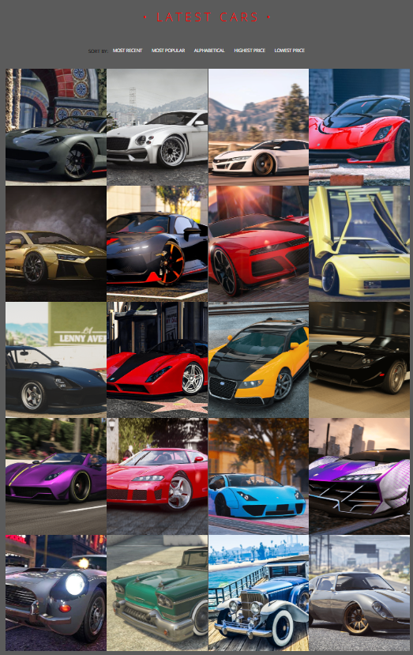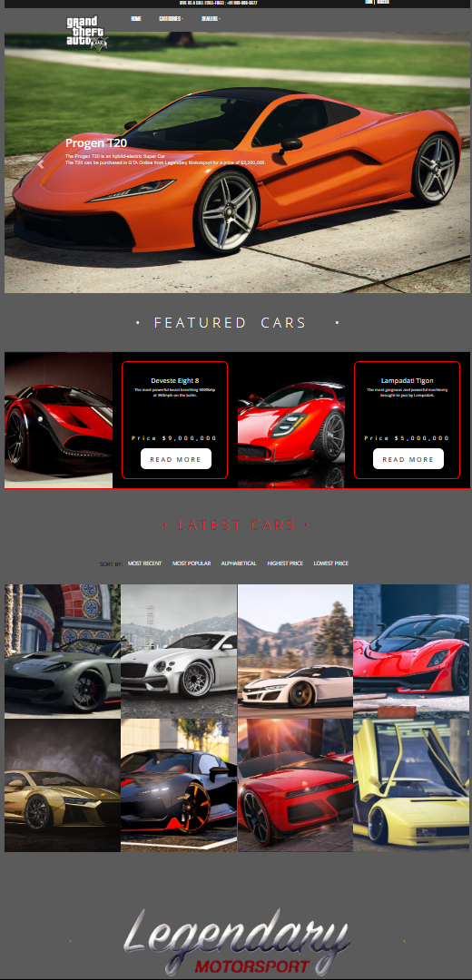

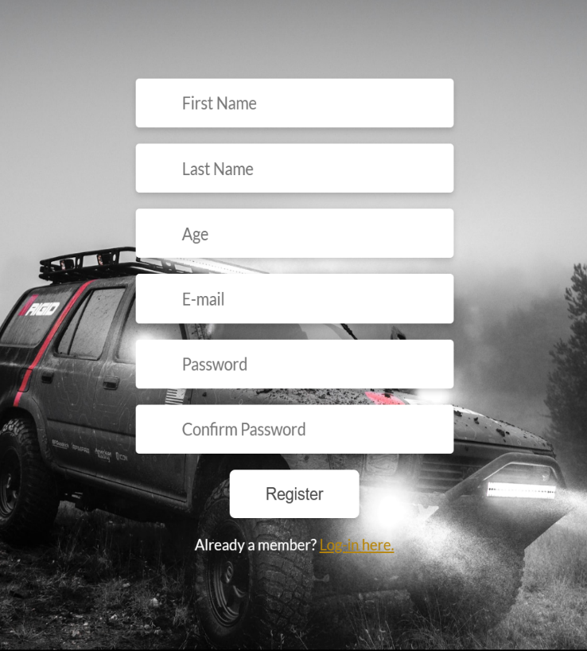

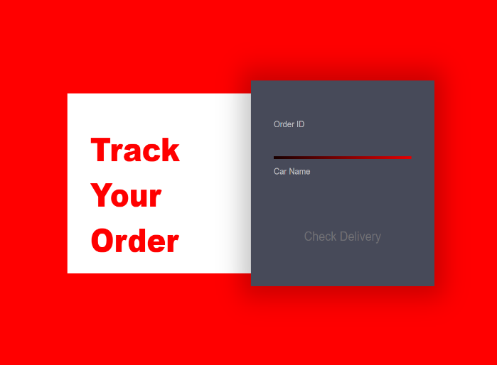

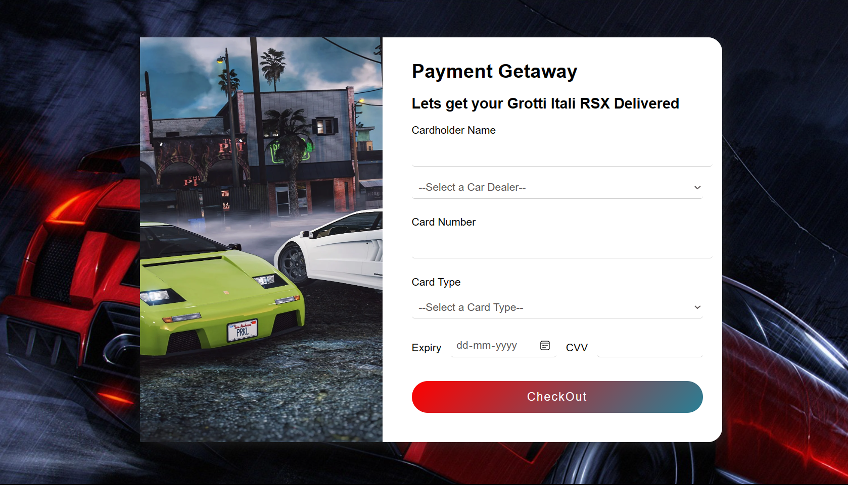

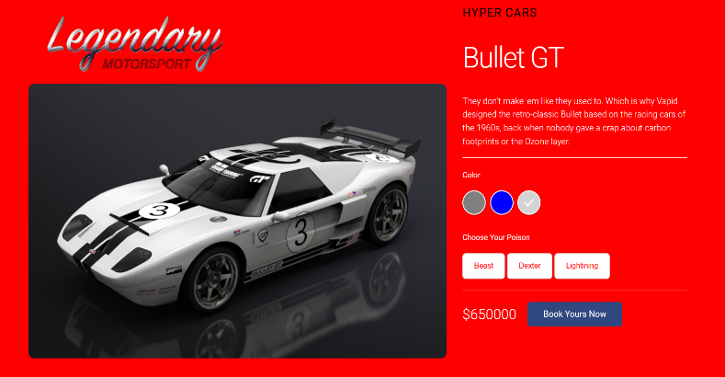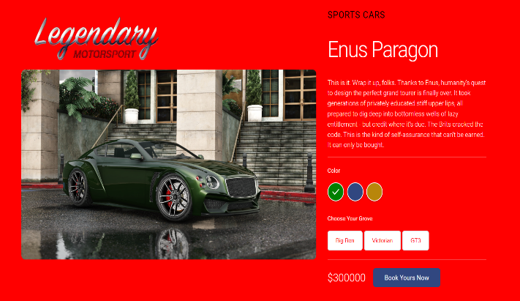

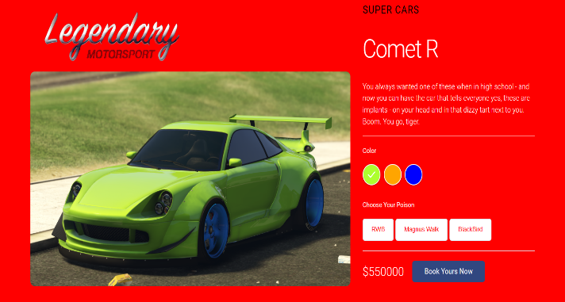

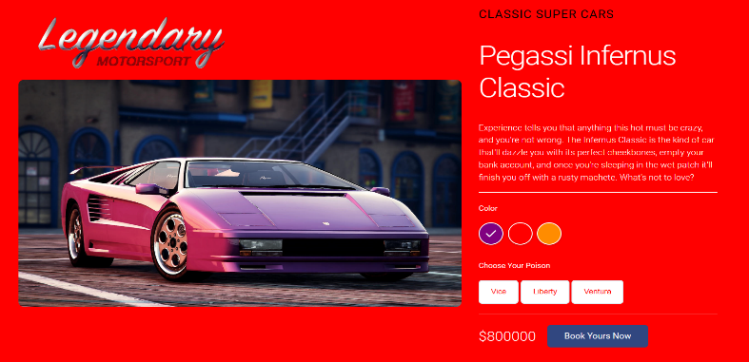

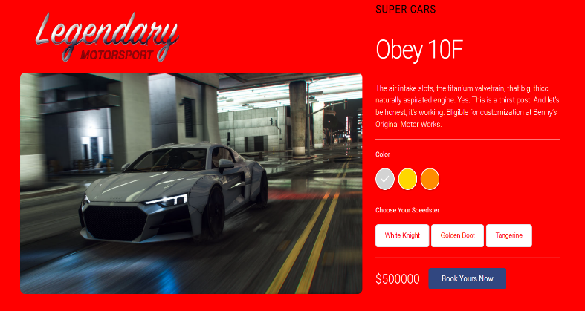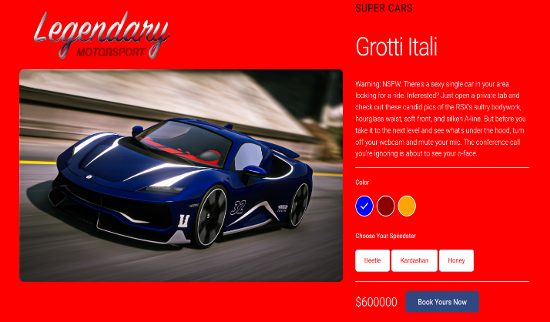

**Conclusion**

The development of Legendary Motorsport successfully achieved its objectives, creating a robust car dealership website centered around GTA 5 vehicles. The website offers an engaging user experience, providing users with the ability to browse, purchase, and track their orders. The incorporation of user registration and login enhances personalization and allows for a seamless shopping experience. The implementation of a well-designed inventory management system ensures accurate stock information. Overall, Legendary Motorsport provides a comprehensive and efficient platform for GTA 5 car enthusiasts to explore and acquire their favorite virtual vehicles.

While this project report highlights the successful implementation of Legendary Motorsport, there are opportunities for future enhancements. These could include expanding the car inventory, implementing advanced search filters, integrating social media features, and optimizing the website for mobile devices. Continuous updates and improvements will contribute to the long-term success of Legendary Motorsport as a premier destination for virtual car enthusiasts.